Waihangahia te Pūrākau

- He aha ngā wāhanga o te pūrākau?
What are the parts of a pūrākau?

- He aha ngā tohu tuhituhi ka kitea i roto i te pūrākau?
What are the written features identified in a pūrākau?

- He aha ngā āhuatanga reo o te pūrākau? (Tuhia ētahi tauira o ngā momo reo ki te papamā hai kōrerotanga).
What are the types of language in pūrākau?

  - Te reo whakaahua (kiripuaki, tūtohu whenua)
Descriptive language (characters, landmarks)

  - Te reo whakaraupapa (kia pai te rere o te kōrero)
Sequencing (to ensure the story flows)

  - Te nuka reo (ngā whakarākeitanga)
Literary devices (embellishments, Māori phraseology, kīwaha, whakataukī etc)

  - Te tohu tuhituhi (ngā kārawarawatanga)
Features of written language (punctuation, paragraphs, grammar)

E hiahiatia ana:
- A selected pūrākau (one that is being studied, or known)
- A series of pictures that relate to the pūrākau
- Examples of phrases and language noticeable in pūrākau

Hai Mahi:
- Use the pictures below to create the pūrākau
- Remember to use the relevant language structures used to write pūrākau.
- Look at the picture then write your kōrero in the box provided (the first one has been done for you).

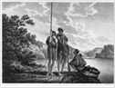 | I ngā wā o mua, i āhua tau te noho o ngā tīpuna ki te whenua. Heoi anō ... | 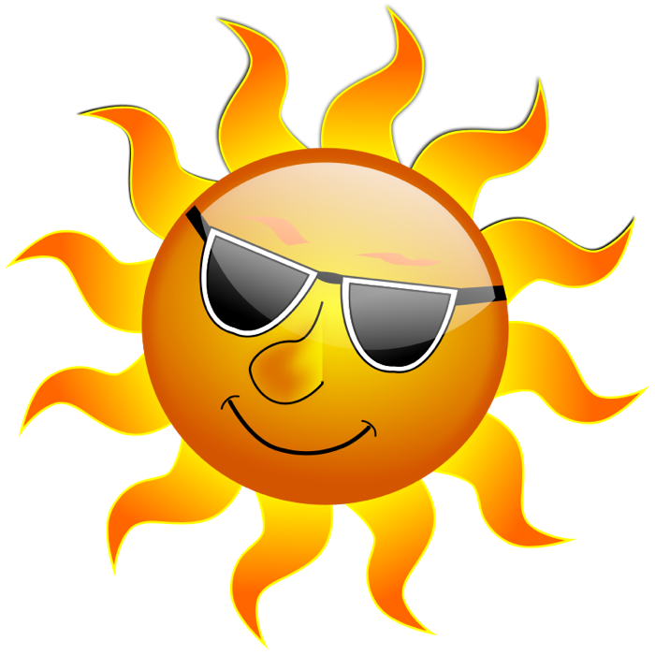
Write text here | 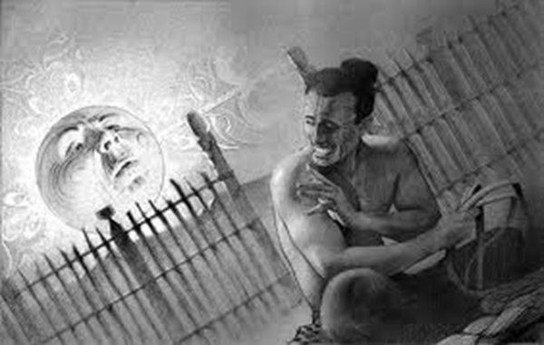 | Write text here
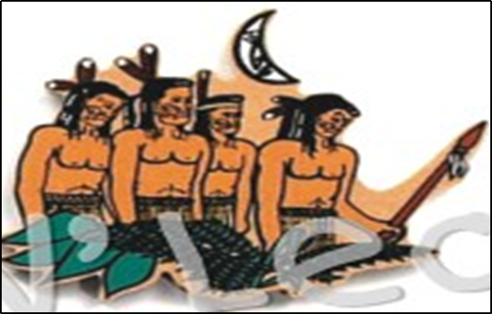 | Write text here | 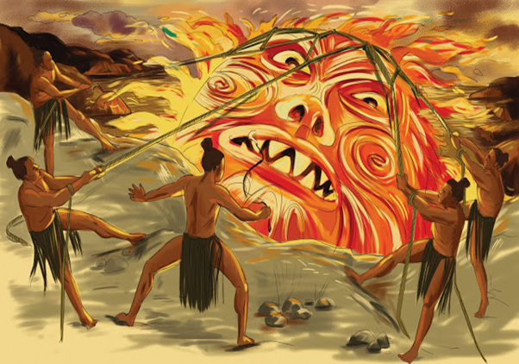
Write text here | 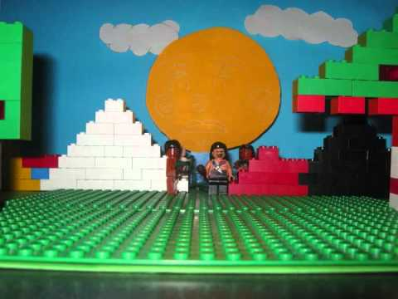 | Write text here

